using marmoset to practice coding C++

Table of Contents

table of contents 1

introduction 1

first submission challenge 1

dev c++ project setup 1

starting new project 1

renaming main.cpp 1

write and test code 2

accessing marmoset 2

Submitting code for grading 3

Checking results 4

test results 6

incorrect file names 7

# introduction

The Marmoset system is an automated code test system. You can use it to check the correctness of your code when solving practice problems.

# first submission challenge

Create a C++ program to output “Hello World!”.

Name the file hello_world.cpp.

Submit your code to the Marmoset code testing server for grading.

# dev c++ project setup

## starting new project

Start by creating a new folder for your project in your code folder. Generally, this is on your UW Nexus N: drive. Name the folder ‘hello_world’.

Start up Dev C++.

Start a new project by selecting from the menu New -> Project…

Select ‘Console Application’ from the New Project window.

Name your project ‘hello_world’.

Click ‘OK’.

## renaming main.cpp

On the left sidebar, within the ‘Project’ tab, you should see the newly created ‘hello_world’ project.

Expand the ‘hello_world’ project folder by clicking on the plus sign. You should see a ‘main.cpp’ file.

Right-click on the ‘main.cpp’ file. You should see a menu pop-up.

Select ‘Rename File… (F2)’.

Change the name of the file to ‘hello_world.cpp’.

## write and test code

Create your program by editing the ‘hello_world.cpp’ file.

Save your code file.

Compile and run your program. From the menu select Execute -> Compile & Run.

If the program successfully compiles, you will see a console window pop up and your program will run. You should see the phrase “Hello World!” printed in the console window.

If your program does not successfully compile, you should see error messages at the bottom of the Dev C++ window. You will need to fix these errors before attempting again to compile and run your program.

Once you have a successfully running program, continue below to submit your code for auto-grading in the Marmoset system.

# accessing marmoset

To access the Marmoset system, point your web browser to <https://marmoset-eugo-2.uwaterloo.ca>. You will be required to sign in to the University of Waterloo Central Authentication Service.

If you are accessing from outside the University network (i.e. through an external Internet Service Provider), you will need to connect through the University’s Virtual Private Network (VPN) service. You can find information about how to use the VPN at the web page <https://uwaterloo.ca/information-systems-technology/services/virtual-private-network-vpn>. You can either use the in-browser VPN connection or install VPN client software on your computer.

Once logged in, you should see a screen similar to the following. Click the “Authenticate as…” button.

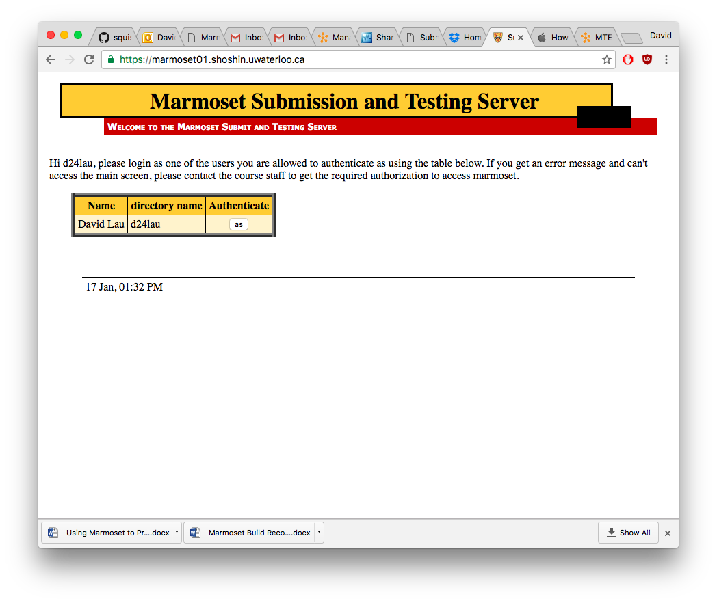

You should see a page showing the available projects:

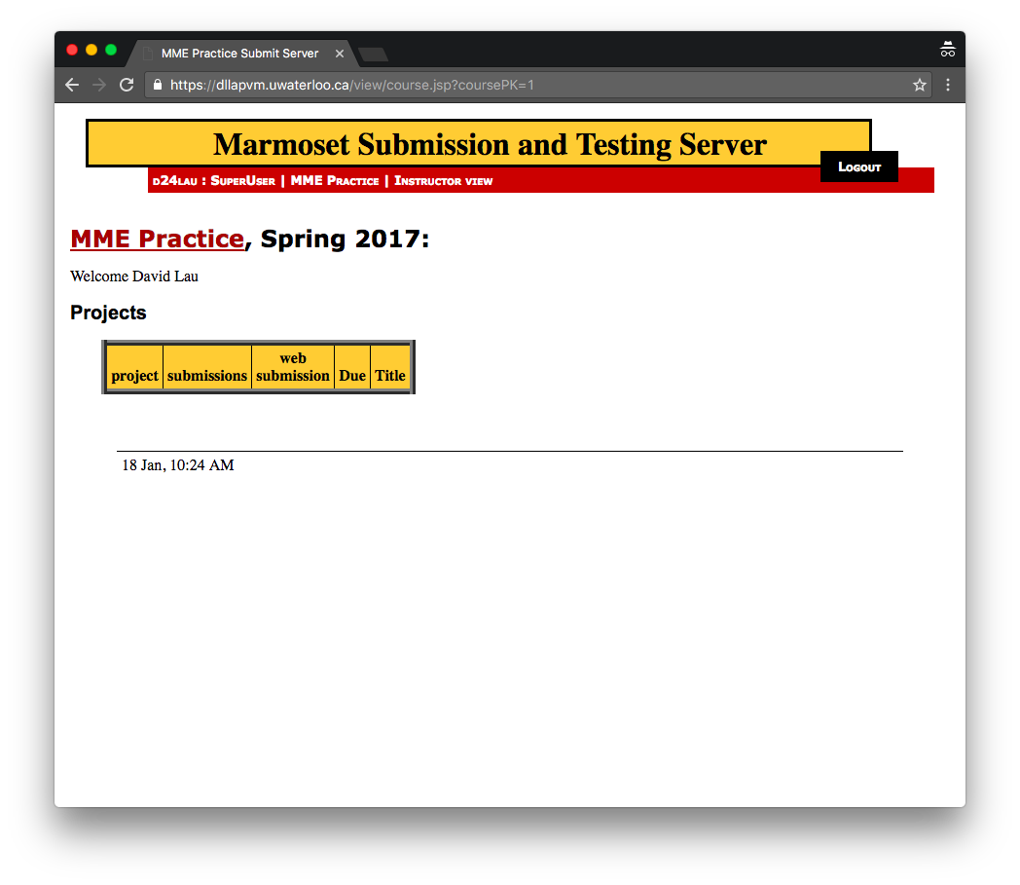

# Submitting code for grading

From the table of projects, click the ‘submit’ link for the project ‘First Submission’.

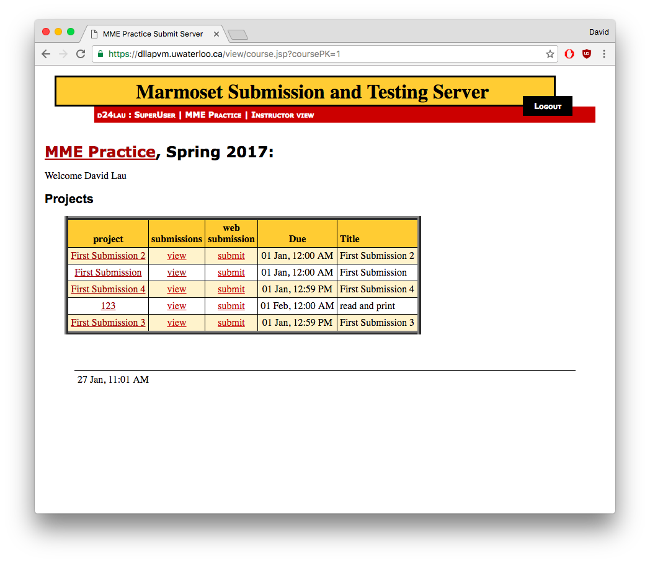

Click the ‘Choose File’ button and then select your hello_world.cpp file. Note that the filename is case-sensitive and has to match ‘hello_world.cpp’ exactly or else it will not compile and cannot be tested.

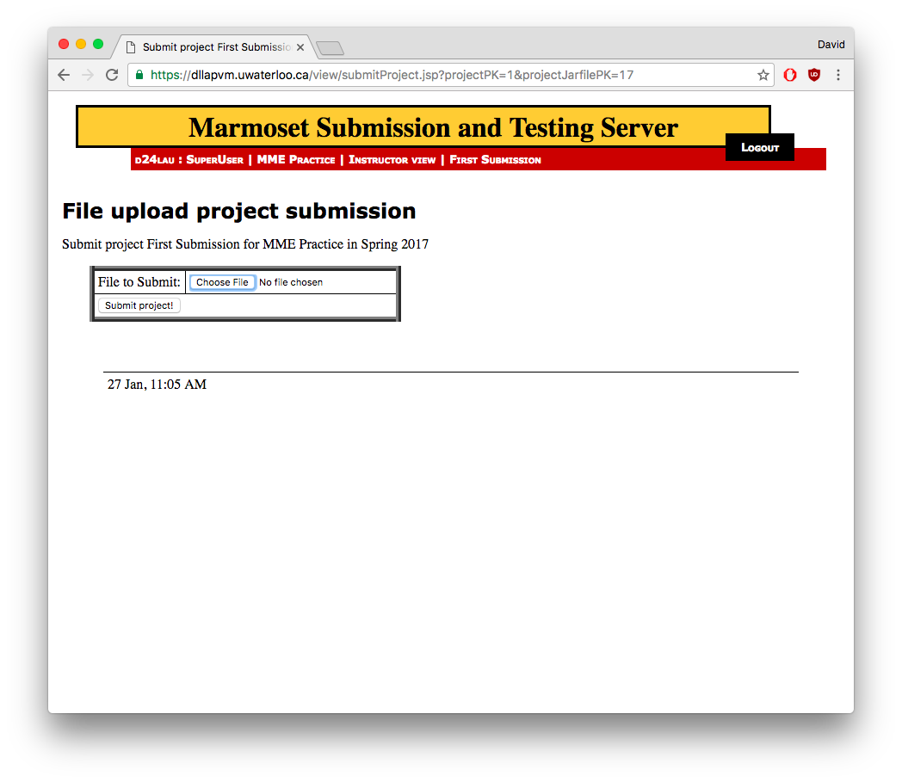

Click the ‘Submit project!’ button.

# Checking results

Upon successful submission of your code, you will find your submission listed on the Submissions table. The ‘public test score’ and ‘detailed test results’ fields will be shown as ‘not tested yet’.

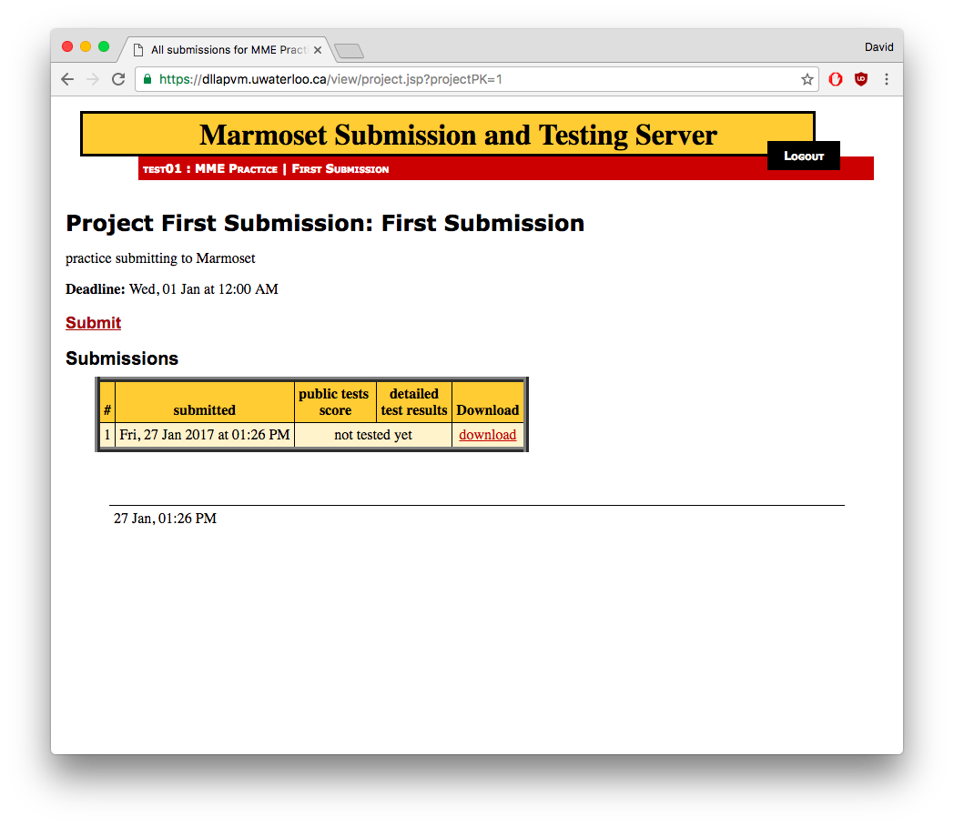

It can take 2 to 10 minutes for your code to be tested. When more students are submitting code simultaneously, response times will be longer.

Periodically refresh the web page to check if your code has been tested yet. Once the server has successfully run your code, you will see a score and a link to view details of the test results.

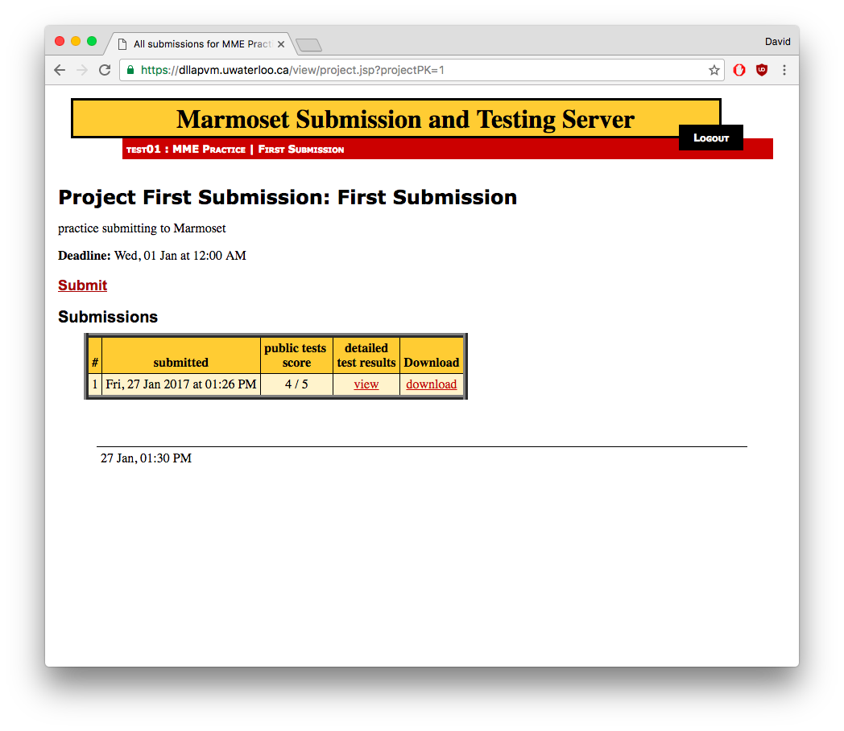

# test results

When you click the ‘view’ link under ‘detailed test results’, you will see test results for individual test cases.

The ‘name’ column can give you some information about what the test case was looking for. The ‘long result’ column will often contain information about the specific output from your program when it was run. This information is often helpful in troubleshooting or debugging your program.

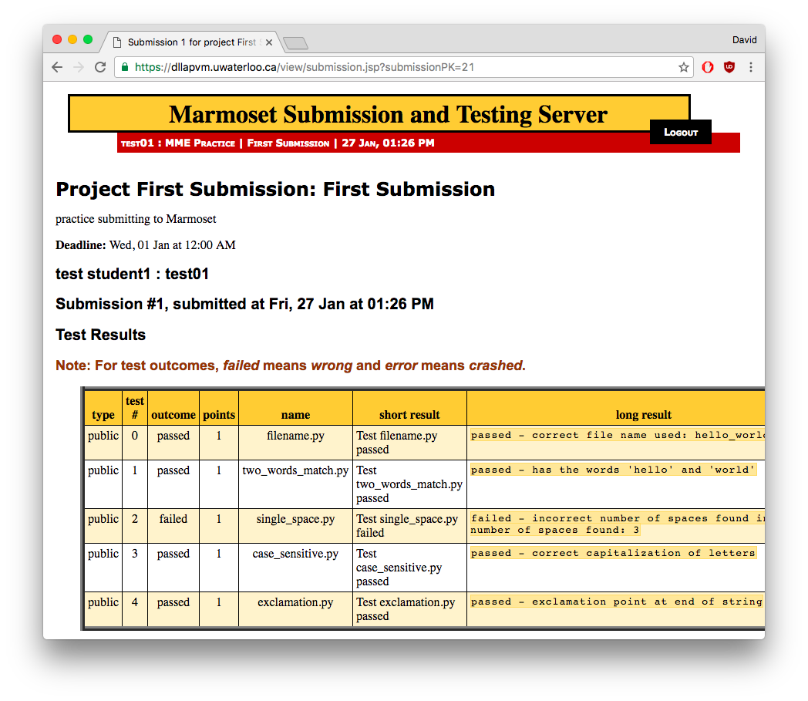

# incorrect file names

Marmoset requires that the file name for your code exactly match its specified file name, including case sensitivity. If your code file name does not match exactly (in this case hello_world.cpp), Marmoset will be unable to compile, run, and test your code.

If your file name does not match, the test details error message will look something like the following:

